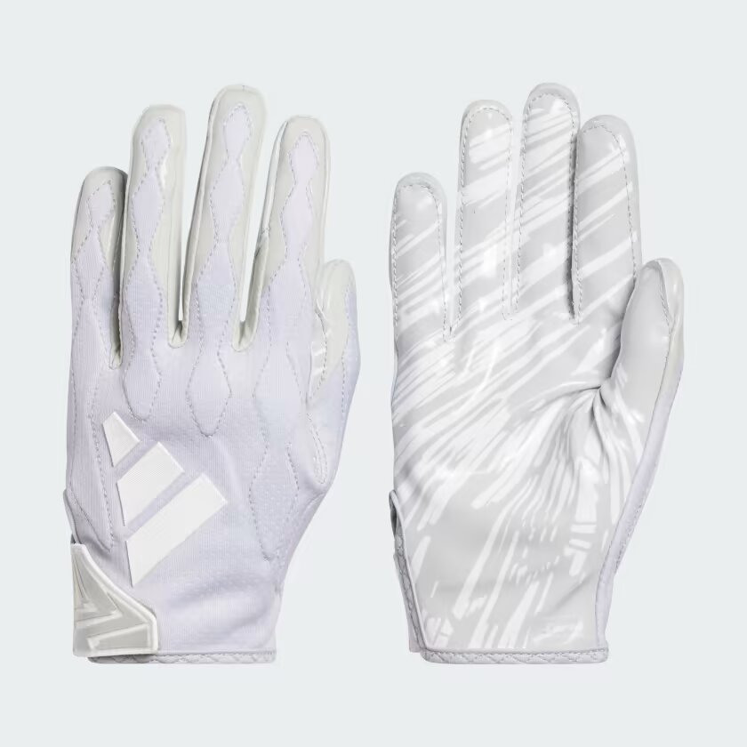

ADIDAS Freak 6.0 Gloves

The Men's adidas Freak 6.0 Football Gloves feature a durable synthetic construction for maximum protection and grip. The lightweight design provides a snug fit to ensure stability and comfort while playing. These gloves are designed with an extended palm, providing superior coverage and protection when catching and handling the ball. The textured palm and fingers offer superior grip and ball control, so you can make plays with confidence. Plus, the wrist strap closure allows for a secure and adjustable fit, so you have the flexibility to play at your highest level. Take control of the game and get your pair of adidas Freak 6.0 Football Gloves today!

**DETAILS:**

* Imported
* Product color: Grey
* Product code: IR3815